**AI and Edge Computing – Batch 05**

**Design Thinking**

**PHASE 1:**

**Stage 1:**

|  |  |  |  |
| --- | --- | --- | --- |
| **Brainstorming** | **Tool** | **Outcome** | **Metrics/Rubric** |
| **Autonomous Navigation System for Factory Floor Robots (AGVs)**  **Sensors:**  Ultrasonic (1), IR (1), PIR (1)  **Problem Description:** AGVs must navigate safely around humans and obstacles on a busy factory floor. Sensor data (Ultrasonic, IR, PIR) is uploaded to a cloud ML platform that drives navigation decisions. Data analytics identify movement bottlenecks, high‐traffic zones, and route efficiency. Visual dashboards support traffic optimization, reduce collision risk, and improve overall productivity and safety. | **Challenges:**  Dynamic appearance of humans and forklifts on the same floor.  Real‐time obstacle detection when multiple AGVs converge.  Low‐latency path planning vs. cloud round‐trip delays.  **Opportunities:**  Use historical traffic data to pre‐emptively reroute AGVs and avoid future congestion.  Leverage cloud ML to continuously improve object‐recognition.  Predictive maintenance: flag AGVs that deviate from optimal paths as early indicators of wheel/motor wear.  Zone‐based dynamic speed adjustments.  **Idea: Alternate Path Planning**  If the AGV spots an obstacle, its onboard controller quickly picks a new route from the local map and sends only essential event data to the cloud.  **Type:** Industrial robotics / Automation project.  **Domain:** Factory automation / Smart manufacturing / Robotics.  **Stakeholders:** Factory managers, AGV operators, Safety officers, Maintenance team, IT/OT integrators.  **Technologies:** Ultrasonic sensors, IR sensors, PIR sensors, Cloud platform, ML algorithms, Visualization tools. | **Refined Project Statement:**  A Smart AGV Navigation System that can:  1. Fuse Ultrasonic + IR + PIR sensor data on-board to detect humans, forklifts, and static obstacles in real time.  2. Execute alternate path planning locally to avoid newly detected obstacles with low latency.  3. Stream only critical events (AGV position + obstacle tag) to a cloud ML platform.  4. Use historical logs in the cloud to identify traffic bottleneck zones and update local AGV route preferences (e.g., avoid “High-density Zone A” during peak hours).  5. Apply zone-based dynamic speed limits: slow down in human-traffic corridors.  6. Provide a real-time dashboard showing AGV heatmaps, current traffic flow, and predicted congestion. | 1. The problem is restated with deep insight (combining real-time detection, latency constraints, and continuous ML refinement). Outputs include precise details: which sensors, which path-planning algorithm, what data is streamed, and how cloud analytics feed back into local decisions.  2. The problem is restated with good insight, but some outputs are still slightly vague.  3. The problem is high‐level, and outputs remain vague. |

**Stage II:**

**Mindmap:**

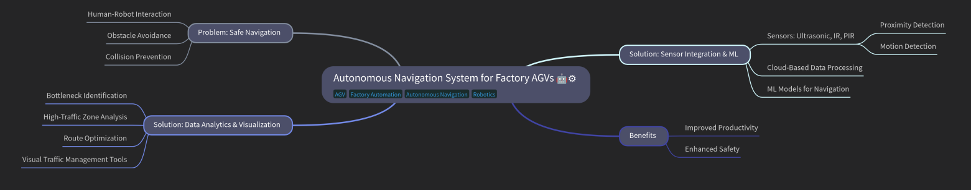

**Abstract:**

The proposed model focuses on developing an Autonomous Navigation System for Automated Guided Vehicles (AGVs) within factory environments. The core challenge addressed is ensuring **safe navigation**, particularly through efficient human-robot interaction, obstacle avoidance, and collision prevention. The model integrates **multi-sensor technology,** including ultrasonic, infrared (IR), and passive infrared (PIR) sensors, for real-time **proximity and motion detection.** Sensor data is processed through **cloud-based infrastructure,** enabling **machine learning (ML) models** to guide intelligent path planning and decision-making.

In parallel, the system incorporates **data analytics and visualization tools** to monitor and optimize AGV performance. This includes identifying bottlenecks, analyzing high-traffic zones, and implementing route optimization strategies supported by visual traffic management interfaces. Together, these solutions significantly enhance **factory automation** by improving operational **productivity** and ensuring **worker safety** in dynamic industrial settings.

**PHASE 2:**

**Stage III:**

**Factory Floor Supervisor:** Understand pain points with daily AGV operations and tracking.

**Operations Manager:** Explore efficiency, delay issues, and need for optimization tools.

**Data Analyst:** Understand data needs, visualization requirements, and reporting challenges.

**Safety/Compliance Officer:** Address safety concerns, AGV-human interactions, and incident prevention.

**Maintenance Team:** Understand diagnostic needs and difficulties in AGV repair/troubleshooting.

**Questionnaire:**

**Instructions:**

Please answer the following questions based on your experience with AGVs in your facility. All responses will remain confidential and used only for academic research purposes.

**Please indicate your role in the factory environment.**

☐ Factory Floor Supervisor

☐ Operations Manager

☐ Data Analyst

☐ Safety/Compliance Officer

☐ Maintenance Team

☐ Other (please specify): _______________________

**Factory Floor Supervisor**

1. How do you currently monitor AGV movement across the factory floor?

* Camera feeds and manual observation are used to track AGV movement.

1. Have there been any recent incidents involving AGVs and workers?

* Yes, minor near-misses have occurred due to blind spots.

1. How easily can you identify an AGV that's stuck or underperforming?

* It is difficult without a central dashboard to detect stuck AGVs.

1. How often do you intervene manually in AGV operation?

* Manual intervention is required 2–3 times daily for rerouting or resets.

**Operations Manager**

1. How do AGVs currently impact your overall production flow?

* AGVs increase efficiency but occasionally cause bottlenecks.

1. Do you experience regular delays due to AGV routing inefficiencies?

* Yes, routing inefficiencies often delay material delivery.

1. How do you assess route performance or congestion points presently?

* Currently assessed by manual tracking and worker feedback.

1. Would predictive routing or alternate path suggestions help in your role?

* Yes, predictive routing would greatly improve flow planning.

**Data Analyst**

1. What types of data do you currently collect from AGVs?

* We collect timestamped location data, usage logs, and delivery status.

1. Which metrics are most critical to track for factory logistics?

* Idle time, delivery time, and route overlap are most critical.

1. Do you face issues with accessing or analyzing AGV movement data?

* Yes, real-time data is fragmented and hard to visualize.

1. What analytics tools or platforms do you currently use?

* Excel and basic BI dashboards are currently used.

1. Would heatmaps or congestion visualizations be beneficial to you?

* Absolutely, heatmaps would help identify congestion hotspots quickly.

**Safety/Compliance Officer**

1. Have you recorded any AGV-related safety incidents or near-misses?

* Yes, we’ve recorded a few close encounters in shared zones.

1. How do you currently monitor AGV proximity to human workers?

* Monitoring is done visually and through PIR sensors in high-traffic areas.

1. Would automated alerts for human detection or collision risk be useful?

* Yes, real-time alerts would reduce response time and improve safety.

1. What features would help you feel confident about AGV safety compliance?

* Clear zones, proximity sensors, and automated braking features help ensure compliance.

**Maintenance Team**

1. What are the most common AGV issues you deal with?

* Battery issues and sensor failures are the most common.

1. How do you currently diagnose AGV faults or downtimes?

* Diagnosis is done through manual inspection and system logs.

1. How often do issues go unnoticed until they cause bigger delays?

* Yes, **minor issues often escalate due to delayed detection**.

**PHASE 3:**

**Stage IV:**

**Sticky Notes:**

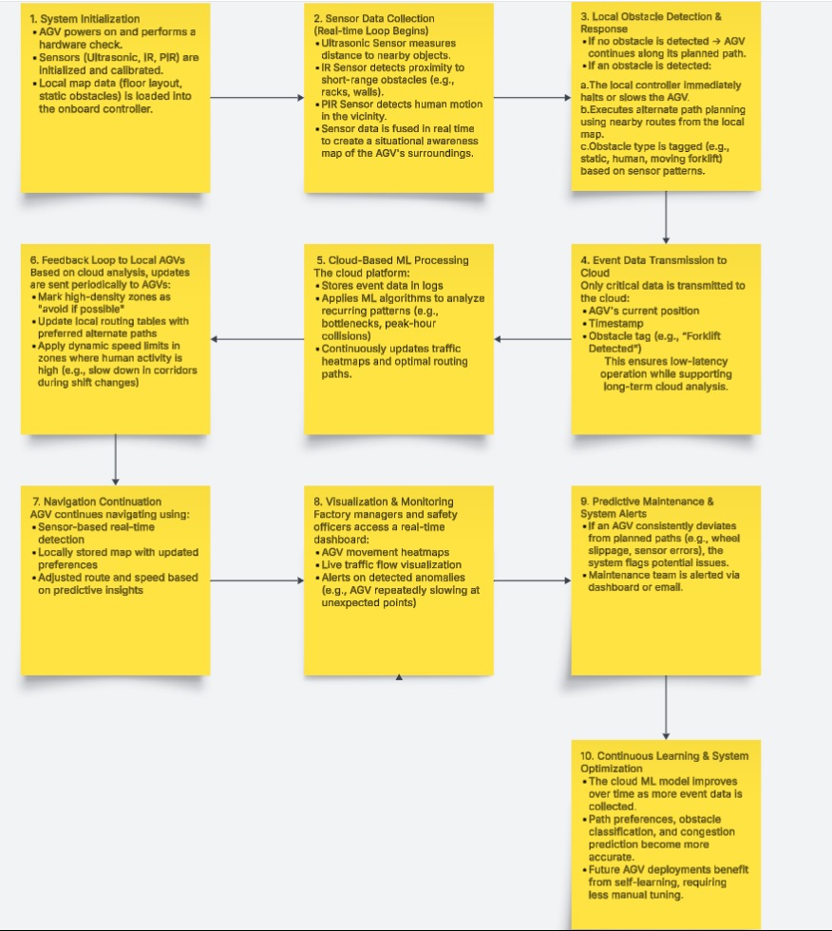

**PHASE IV:**

**Stage V:**

**Project Overview:**

The Smart AGV (Automated Guided Vehicle) Navigation System is an ongoing project aimed at improving autonomous navigation within dynamic factory environments. The system is designed to enhance safety, efficiency, and decision-making for AGVs operating in shared spaces with humans, forklifts, and other moving elements.

The core idea revolves around integrating multiple onboard sensors—Ultrasonic, Infrared (IR), and PIR—to detect obstacles in real time. These detections enable the AGV to make quick local decisions and reroute itself without relying entirely on cloud commands. Simultaneously, critical data such as AGV location, obstacle events, and route history is transmitted to a cloud-based machine learning platform.

This cloud system will analyze historical traffic patterns to identify high-congestion zones, enable predictive maintenance, and optimize route planning. An administrative dashboard will provide real-time visibility into AGV performance, heatmaps, and alerts, supporting data-driven operational decisions.

The project is currently in the development phase, with key components such as sensor integration, route mapping, and dashboard planning in progress. Once complete, this system is expected to significantly reduce collision risks, improve workflow efficiency, and offer a scalable solution for smart factory automation.

**Cost estimation of the project:**

|  |  |  |  |
| --- | --- | --- | --- |
| **Item** | **Quantity** | **Unit Price (Approx.)** | **Total Cost (INR)** |
| Ultrasonic Sensor (HC-SR04) | 1 | ₹60 | ₹60 |
| IR Sensor Module | 1 | ₹25 | ₹25 |
| PIR Motion Sensor (HC-SR501) | 1 | ₹50 | ₹50 |
| Microcontroller (Raspberry Pi Pico) | 1 | ₹400 | ₹400 |
| Motor Driver Module (L298N) | 1 | ₹150 | ₹150 |
| DC Motors with wheels | 2 | ₹150 | ₹300 |
| Chassis (basic 2-wheel robot frame) | 1 | ₹200 | ₹200 |
| Battery (Li-ion pack or 12V battery) | 1 | ₹300 | ₹300 |
| Wi-Fi Module (ESP01 or ESP8266) | 1 | ₹100 | ₹100 |
| Wires, Connectors, Breadboard, etc. | - | ₹150 | ₹150 |
| Dashboard/Server (cloud-based) | - | Free / ₹200 (if needed) | ₹0–₹200 |

Total estimate cost will be approximately ₹1800 to ₹2000

**Path detection mechamism of the project:**

Mechanism Overview:

1. Sensor Fusion (Input Collection):
   1. The AGV is equipped with:
      1. Ultrasonic Sensor – Detects nearby obstacles (static or moving).
      2. Infrared (IR) Sensor – Detects object edges and short-range obstacles.
      3. PIR Sensor – Detects human motion and thermal presence.
2. Obstacle Detection Logic:
   1. If any sensor detects an object within a predefined safety radius, the system flags a path block event.
   2. The AGV pauses immediately and triggers the local path planning module.
3. Alternate Path Planning (Onboard Logic):
   1. The AGV uses a local map (pre-loaded or updated periodically from the cloud) to identify available alternate paths.
   2. A pathfinding algorithm (e.g., A*, Dijkstra, or BFS) computes the next shortest viable route avoiding the blocked node/zone.
   3. Only essential event data (e.g., “Obstacle at Node C4”) is sent to the cloud to update global traffic models.
4. Cloud Feedback (Learning & Optimization):
   1. The cloud logs all such events.
   2. Over time, ML models analyze bottleneck zones, predict congestion, and push updated routing preferences to AGVs.

Step by step flow:

AGV is in motion → Obstacle detected by sensors → Trigger emergency halt + event logging → Run onboard path finding → Select new route → Resume motion → Update cloud with event and selected route